**<Project Title>**

**(MotorBike Karobar)**

### 

**Project Code**

Capstone-1

**Project Advisor**

**Project Manager**

Saad Razzaq

**Project Team**

Muhammad Asad Waqar (BSCS-F17-38) (Team Leader)

Saad Bin Aslam (BSCSF17E026) (Team Member)

**Submission Date**

2 November 2021

**Table of Contents**

1. Abstract 3

2. Background and Justification 3

3. Project Methodology 3

4. Project Scope 3

5. High level Project Plan 3

6. References 3

# Abstract

1. The problem is that, there is no good digitally combined platform for selling and purchasing

of new and used motorbikes, also for bike’s parts and accessories.

1. We want to take this business to digital world where users can search and navigate all about purchasing and selling their motorbikes, parts & accessories whether those are new or used.

# Background and Justification

As I already mention that there is no good digital platform for selling and purchasing of new & used motorbikes, their parts & accessories. We have seen the rush of people present at the specified workshops for purchasing motorbikes and related parts. Lot of people present for reviewing & purchasing and there is no proper place and arrangement, also no good communication system b/w customer and seller. Also there is no price justification system. And if some individual want to sale his/her motorbike then he/she has to face a lot of difficulties like first take his/her bike to some workshop and then there is no management. So, in short there is no digital combined platform for this problem and these are all the main hurdles which people face and we want to solve out these problem domains by providing a platform(website)

There is some, actually I will say a lot of work has been done in this domain but there are lot of things which remains unnoticed and also those works are either very complex for local audience or this domain is a single limited option in some other big domain’s platform which is still a big problem

Like there are two big platforms which are working in this domain in Pakistan :

1. PAKWHEELS.COM is a big platform which is dealing with car business and motorbikes business. And their focus is mostly on cars. Basically divided focus and no system for any individual to sell bike. Also that platform is very complex for local audience and not good in design, in short very unattractive to navigate and spend time on that platform.
2. MOTORCYCLE SHOP is another platform which targets only motorbikes business which is good but there is no system for selling and purchasing of used bikes. Also no system for uploading other than platform’s owner or management. And also no system for any individual or workshop to grow their business on their own.
3. All other platforms are motorbikes official companies owners official websites which are limited and main thing is that not solving our problems.

Now we provide a single specific platform of this domain which deals with all these problems which remains unnoticed and deals with each & everything which can be possible .

**3.Project Objectives/Goals:**

First of all there will be three main parts:

**Bikes side, Bike’s parts side & Accessories side**.

In bikes side there will two parts, first navigating page which will further divide into two parts

Used & New.

Second there will be bikes uploading part for selling which will further divide into two parts Individual & Workshop which will further divide into Used & New.

In bike’s parts side there will be same two parts, first navigating page for purchasing which will further divide into Genuine & China parts which will further divide into New & Used.

Second there will be parts uploading side for selling which will further divide into Individual & Workshop which will further divide into Genuine & china and then further divided into Used & New.

Then there are side categories of :

Installment based or Non Installment

Login Profile

Feedback

Location Manager

Contact

Newsfeed

Reviews

# 4.Project Methodology

In this project we are going to use Modified Waterfall SDLC Model. The following figure is showing the phases which we will use to develop our project. This model is consisting of six phases.

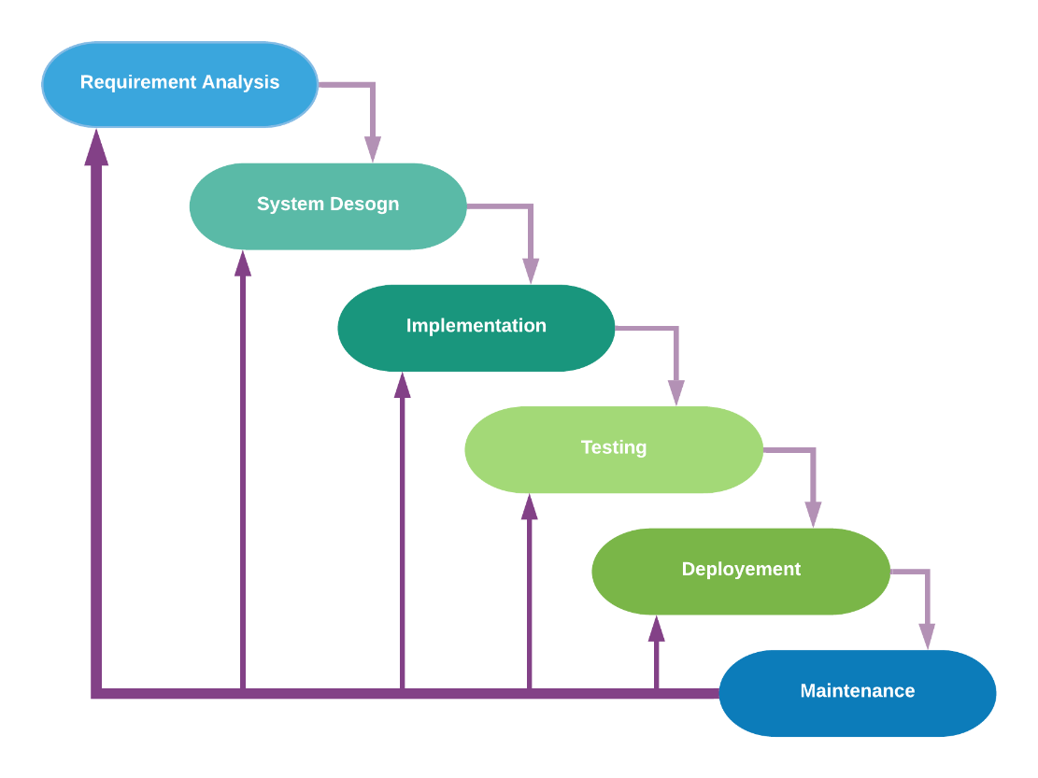

* **Requirements Analysis:**The first phase involves understanding what needs to design and what is its function, purpose, etc. Here, the specifications of the input and output or the final product are studied and marked.
* **System Design:** The requirement specifications from the first phase are studied in this phase and system design is prepared. System Design helps in specifying hardware and system requirements and also helps in defining overall system architecture. The software code to be written in the next stage is created now.
* **Implementation:** With inputs from system design, the system is first developed in small programs called units, which are integrated into the next phase. Each unit is developed and tested for its functionality which is referred to as Unit Testing.
* **Testing:** All the units developed in the implementation phase are integrated into a system after testing of each unit. The software designed, needs to go through constant software testing to find out if there are any flaw or errors. Testing is done so that the client does not face any problem during the installation of the software.
* **Deployment:** Once the functional and non-functional testing is done, the product is deployed in the customer environment or released into the market.
* **Maintenance:** This step occurs after installation, and involves making modifications to the system or an individual component to alter attributes or improve performance. These modifications arise either due to change requests initiated by the customer, or defects uncovered during live use of the system. The client is provided with regular maintenance and support for the developed software. >

# 5.Project Scope

**(Functionalities system will perform)**

MotorBike Karobar will provide a platform for purchasing & selling of motorbikes, their parts & accessories, which can be either new or used.

Everybody can upload his/her bike & parts with all info and status, which can be some workshop, organization or any individual.

One side for navigating platform for purchasing and One side for uploading for selling means.

Proper communication system to contact on both sides.

MotorBike Karobar will provide a platform where you can do 80% of work of this domain while sitting freely anywhere.

**(Functionalities system will not provide)**

MotorBike Karobar will not provide online transaction between two sides.

MotorBike Karobar will not provide pick and drop system.

MotorBike Karobar will not provide personal level legalities of purchaser & seller.

# 6.High level Project Plan

|  |  |  |
| --- | --- | --- |
| **Column1** | **Column2** | **Column3** |
|  |  |  |
|  | **Textile Auxiliaries** | |
| Task | Start Date | Days to Finish |
| Requirements | 31-Oct-21 | 15 |
| Research | 15-Nov-21 | 10 |
| Planning | 23-Nov-21 | 8 |
| Design 1 | 01-Dec-21 | 20 |
| Design 2 | 22-Dec-21 | 20 |
| Design 3 | 15-Jan-22 | 20 |
| Design 4 | 06-Feb-22 | 20 |
| Development | 01-Mar-22 | 30 |
| Testing | 02-Apr-22 | 10 |
| Maintain | 13-Apr-22 | 10 |

Following are the high-level plan of our project. We set the timeline of project from the

# References

Websites already working in this domain:

1. PAKWHEELS.COM
2. MOTORCYCLE SHOP

A senior friend who has some expertise in web development.

Project Supervisor is still not found. We will definitely discuss with him and ask for more improvements & expertise.